**DEMOLITION, REMOVAL AND DISPOSAL OF OLD SITE WATER TREATMENT PLANT**

**Guyana Shore Base Inc.** hereby invites interested companies to submit proposals for the Demolition, Removal and Disposal of Old Site Water Treatment Plant.

**Scope of Work**

* Demolition, Removal and Disposal of Old Site Water Treatment Plant.
* Contractor must be QHSSE Compliant.
* Demolition plan must be provided.

**NB: SITE VISIT MUST BE CONDUCTED TO PROVIDE QUOTE.**

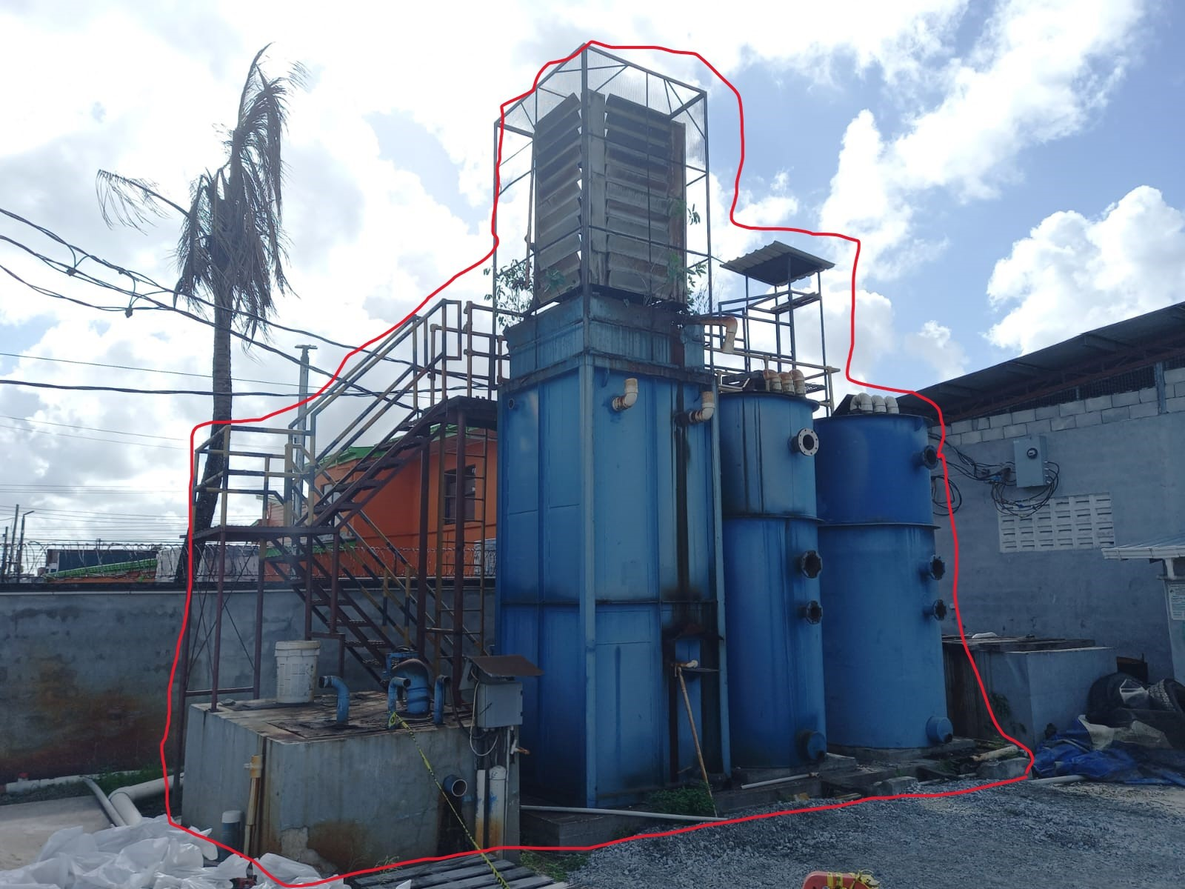

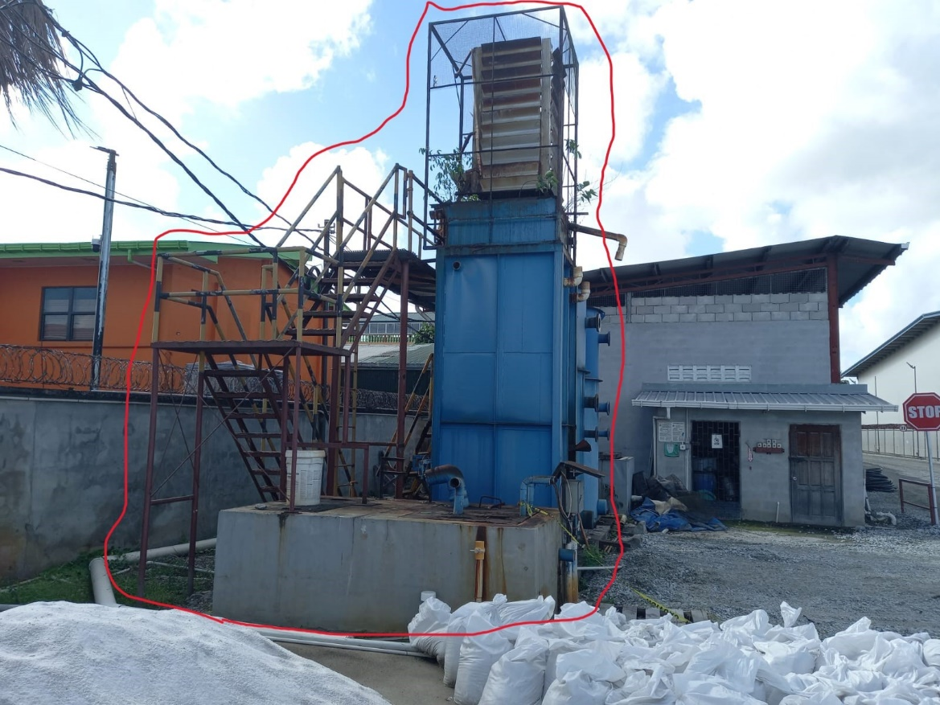

**Instructions to Bidders**

1. Proposals are to be submitted along **Valid Business Registration or equivalent, Valid GRA & NIS Compliance, Local Content Certificate.**
2. Proposal and documents must be submitted to the e-mail address below **on or**

**before 14th March 2024.**

**Release Date: February 29th, 2024**